Date: 6/7 june 7
Aaj
Write csv bnate he.
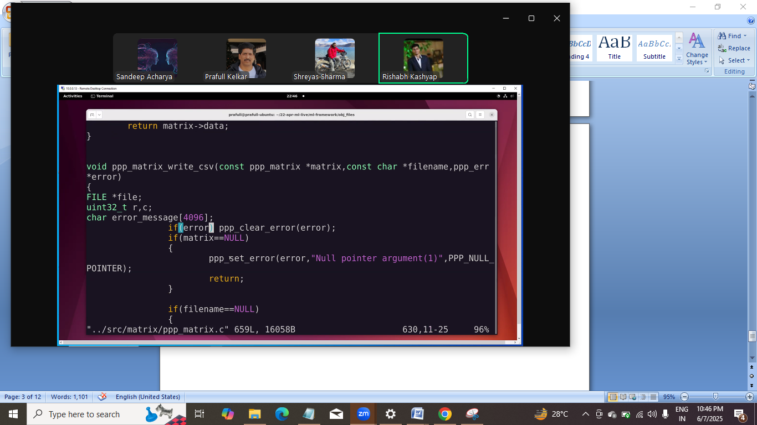
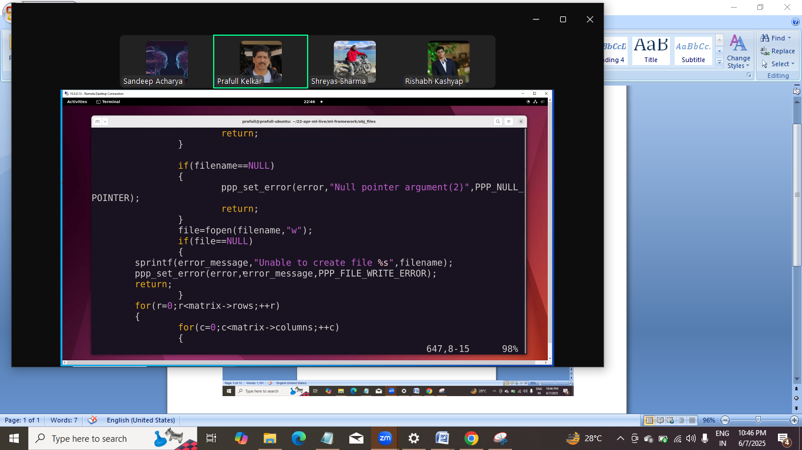
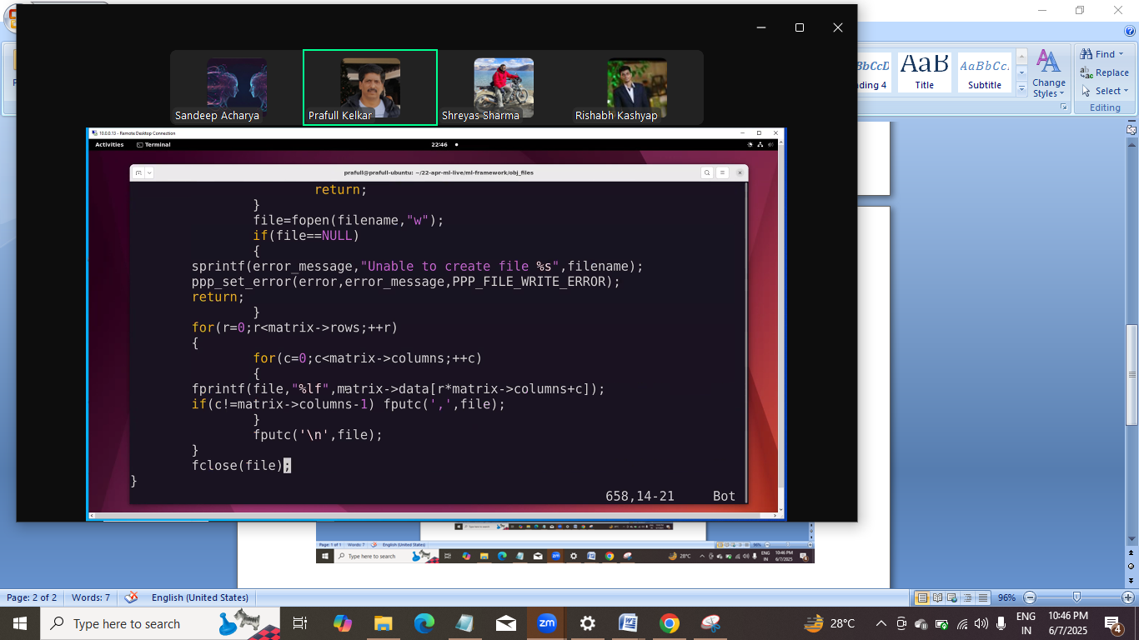
Ye ho gaya write csv wala.
Isko vector me bhi bdana he

Ab utilities bnate he.
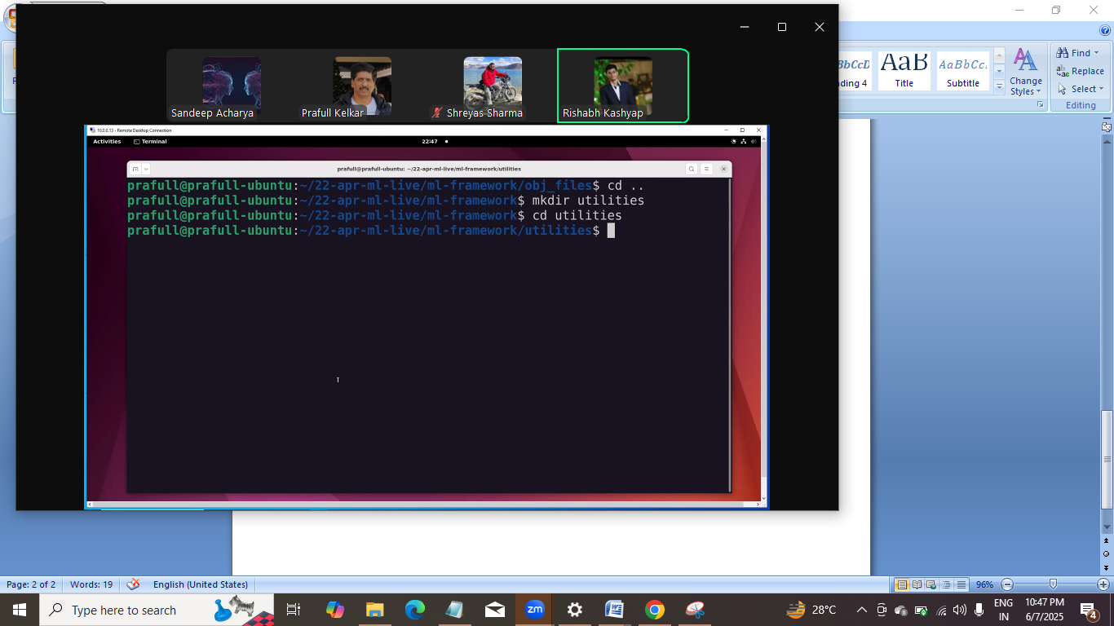

Comare size:
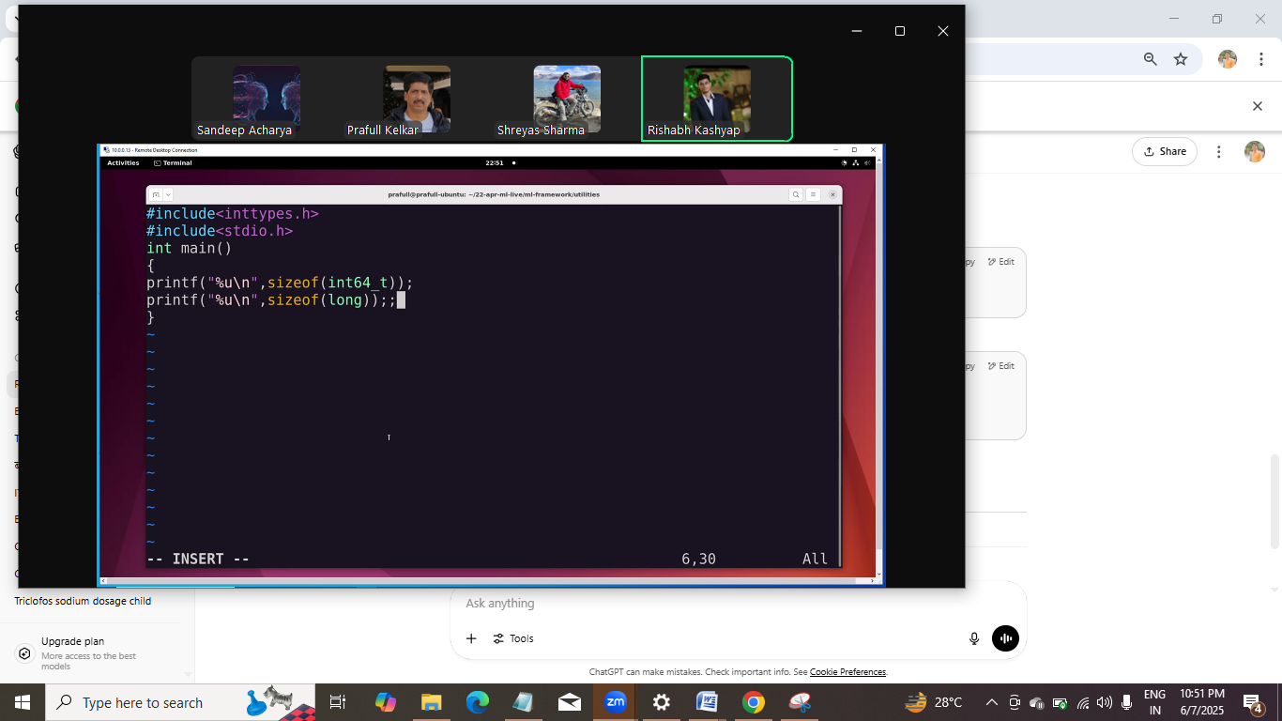
Dataset split krne k liye csv bna rahe he :
Uske liye matrix bna k usme random number dale then usko file me likhege and then usko read kr k split krege. 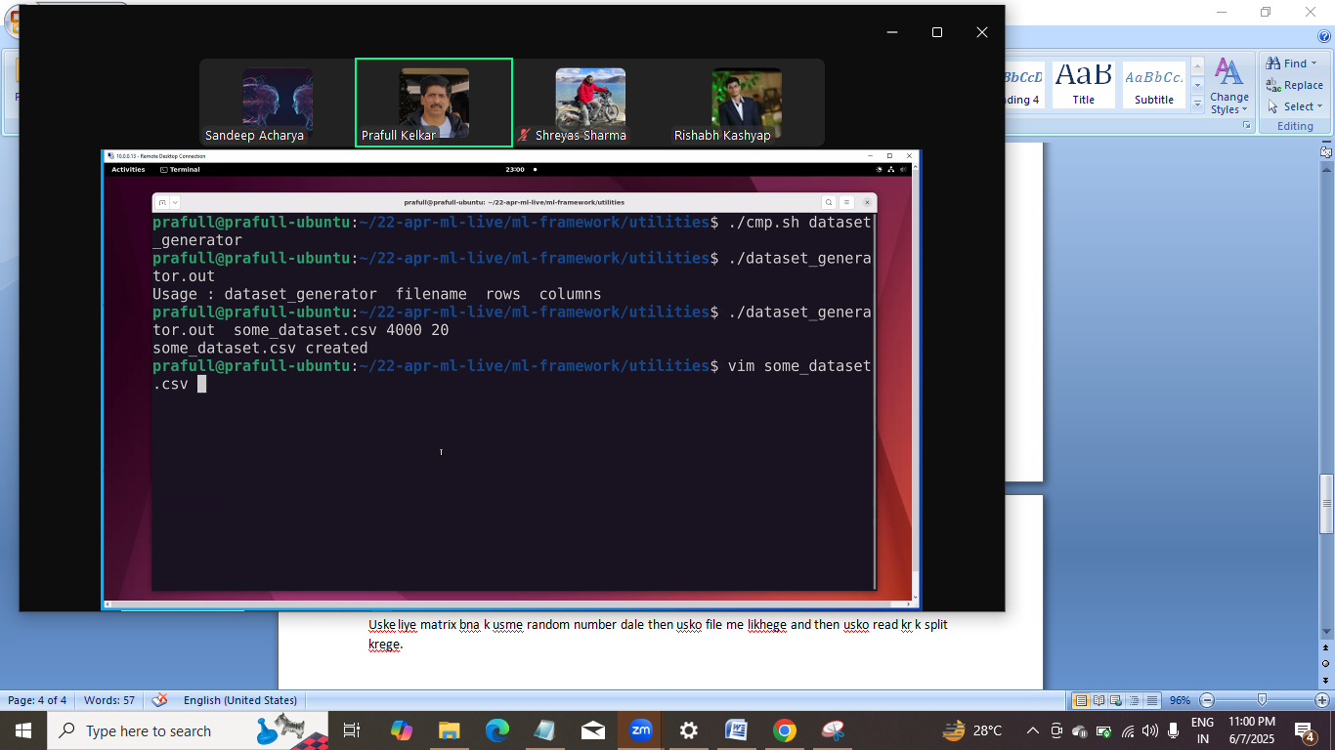

Code:
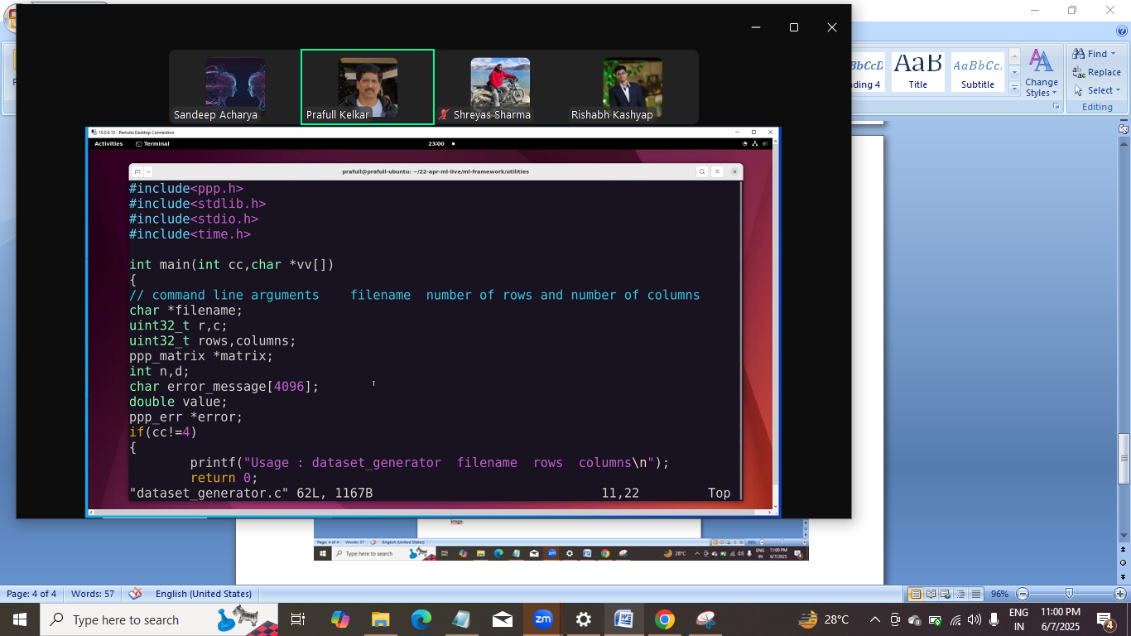
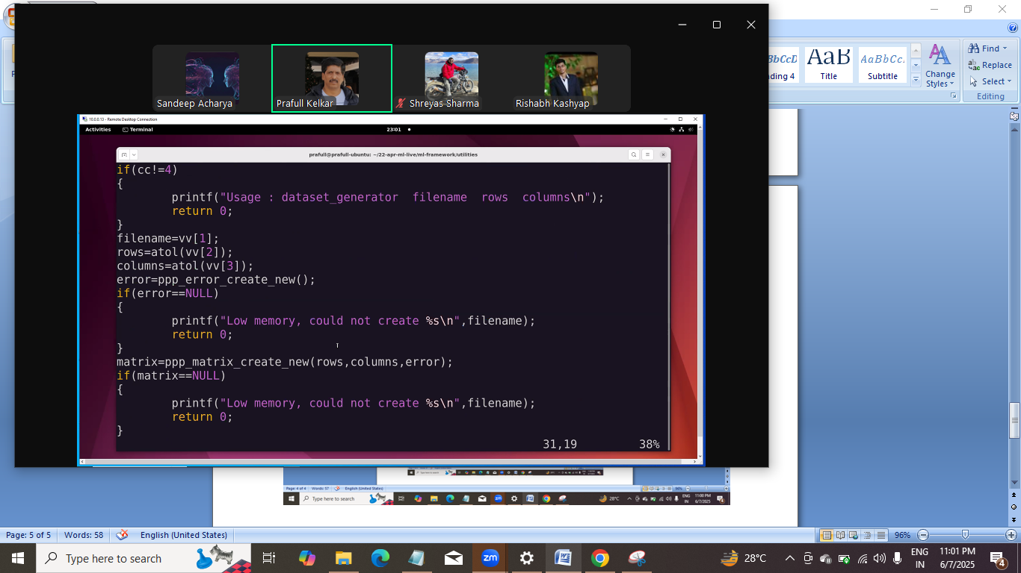

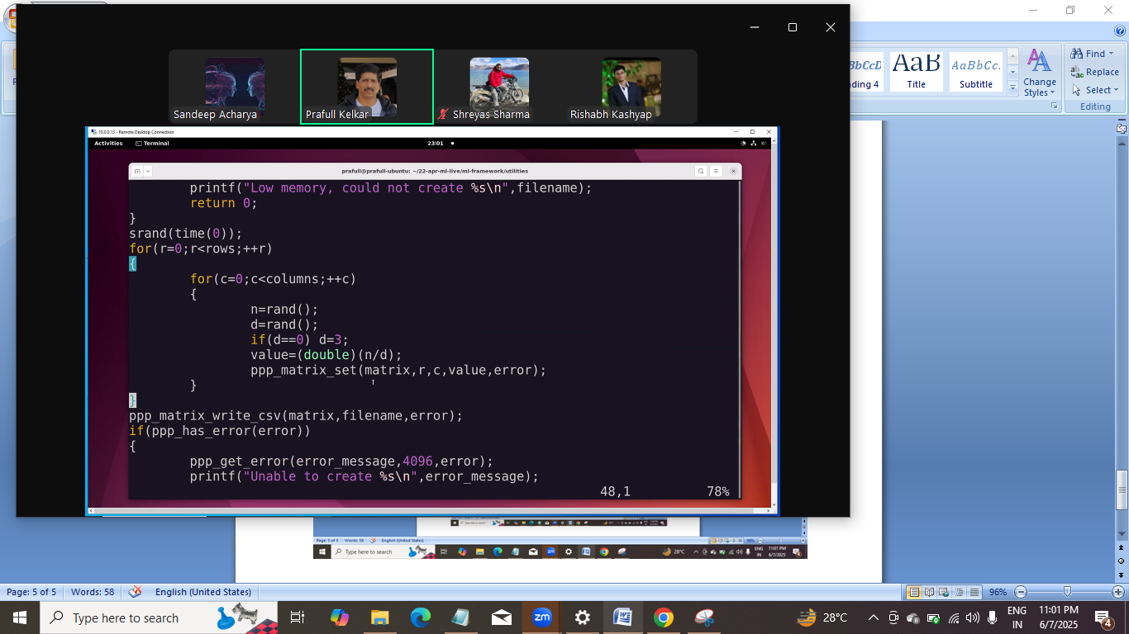
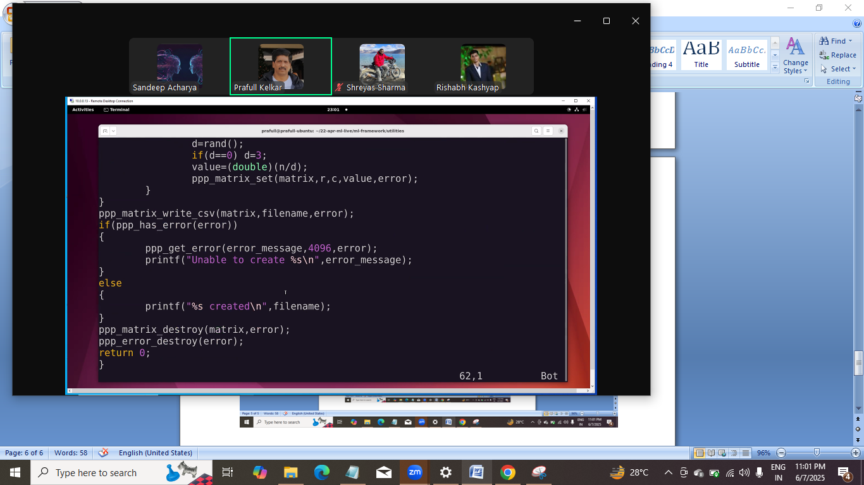
Ye data set generate ka code, ye dataset line wale k liye kaam nahi krege
Ab dataset spliter use krege.
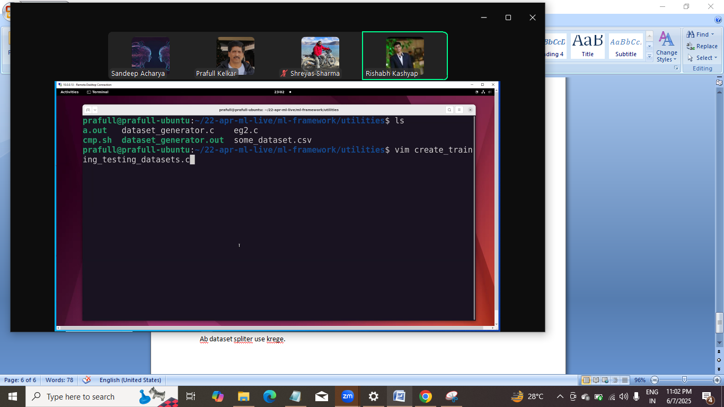
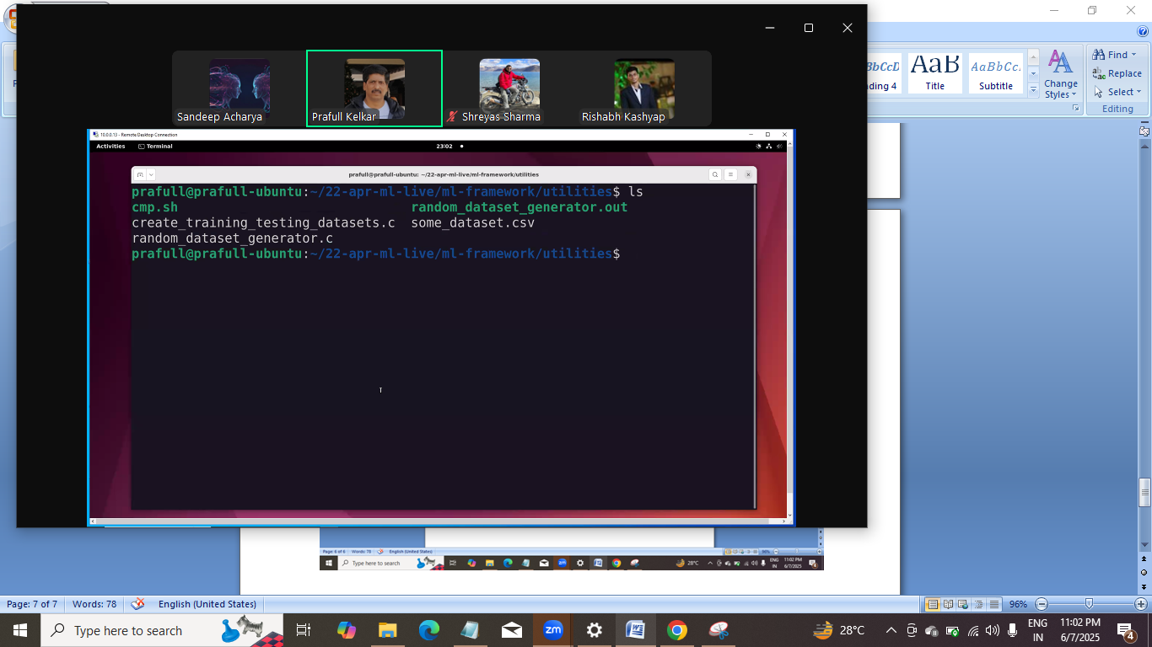

Ab split wale me kya krna he: input csv ko training and testing csv me split krna he.
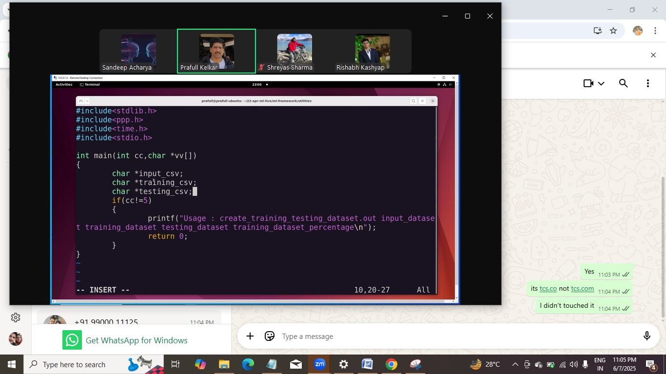

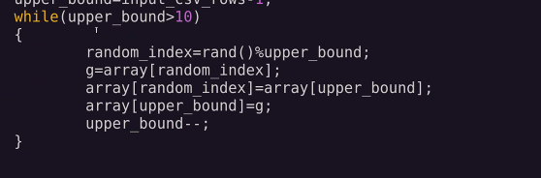
Yaha pr while me > 1 ya >5 ya kuch bhi le skte he.
Csv khol k array me daalne ka kaam ho gaya .
Ab user ne bola ki trainging ko 70% do and testing ko 30% do.
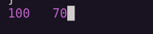
Ya phir esa kr skte he:
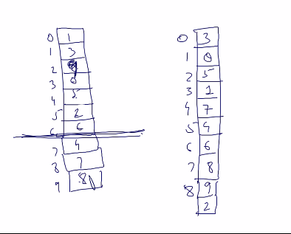
Ek single traverse me number read kiya and us no. k index pr index likh diya, dusre array me.
Ye raha vo logic:

Now:
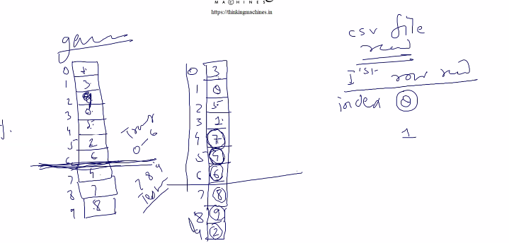
1st wali pattti k hisab se 0-6 training me , 7-9 ka test me

To 2nd wali patti me dekhege ki jo value aayi he vo 0-6 k bhich ki he ya 7-9 k bich ki , based on that hm usko us catergory me daal dege.

Ese compile and test:
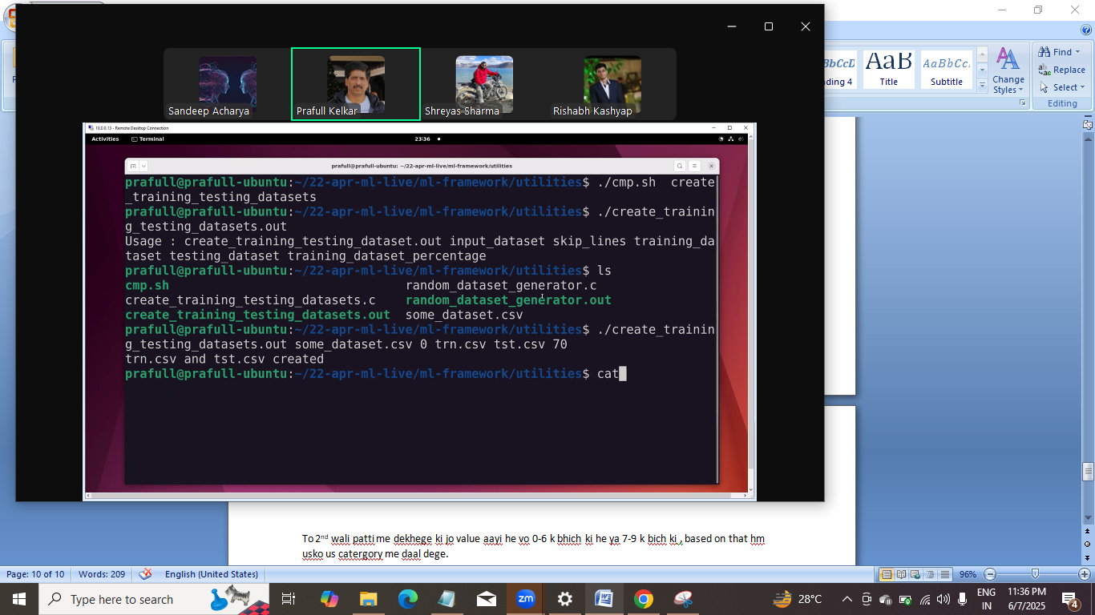

Code:
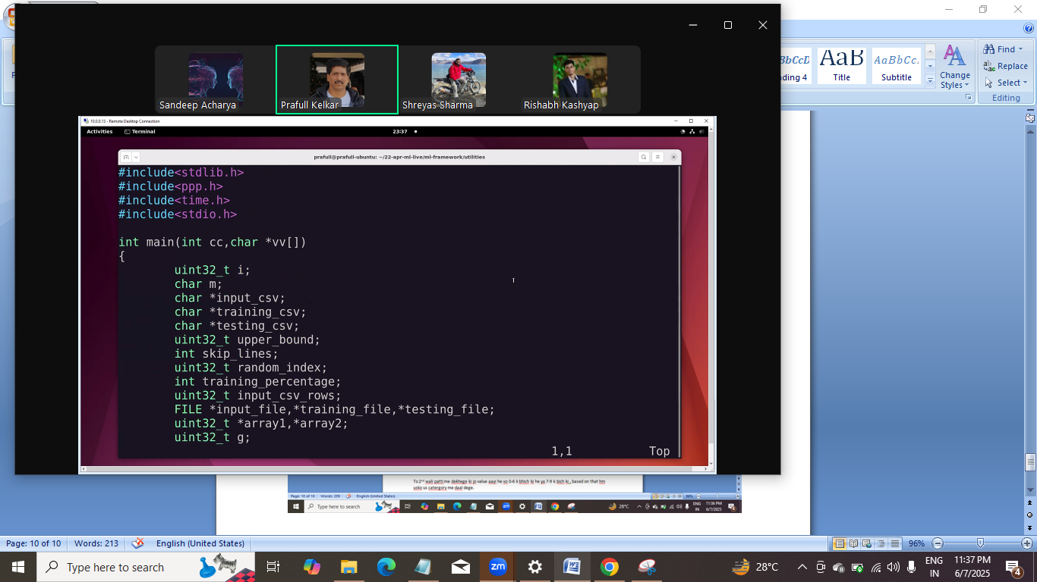
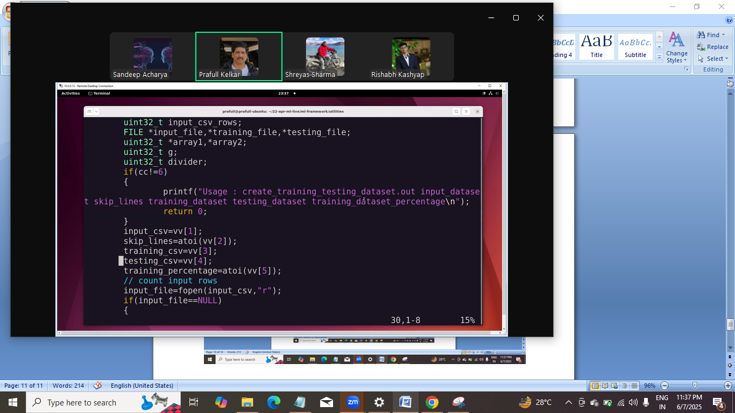
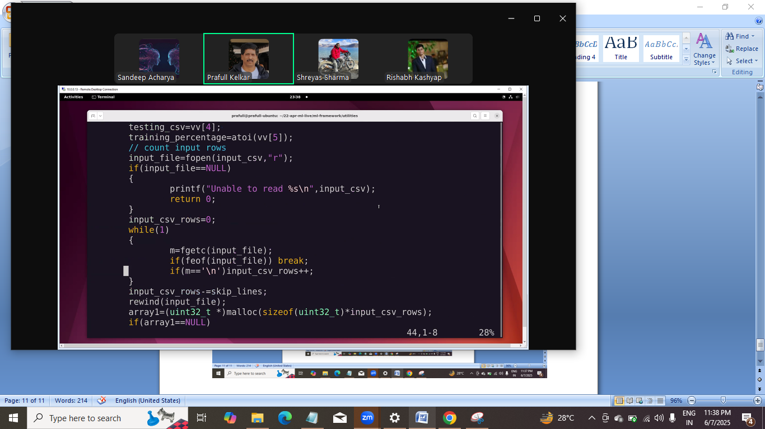
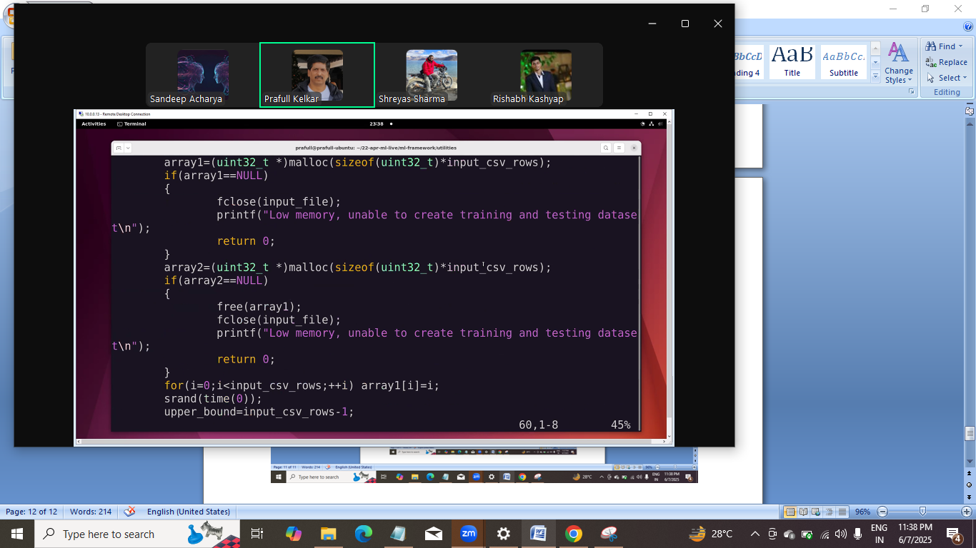
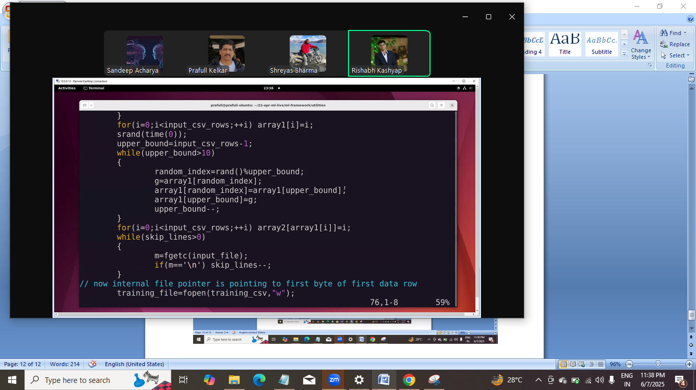
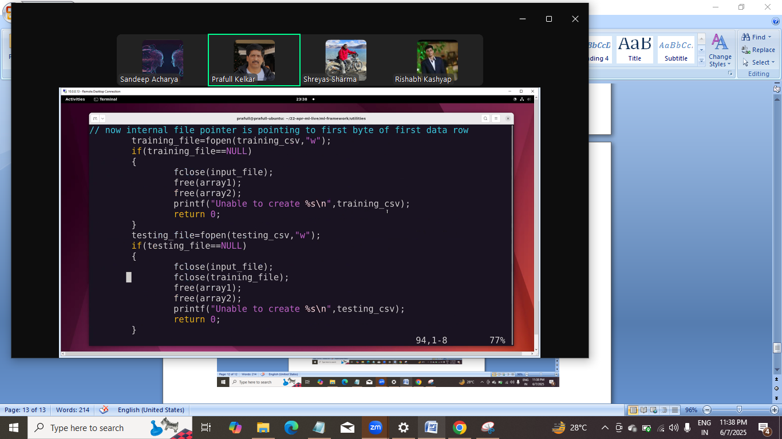
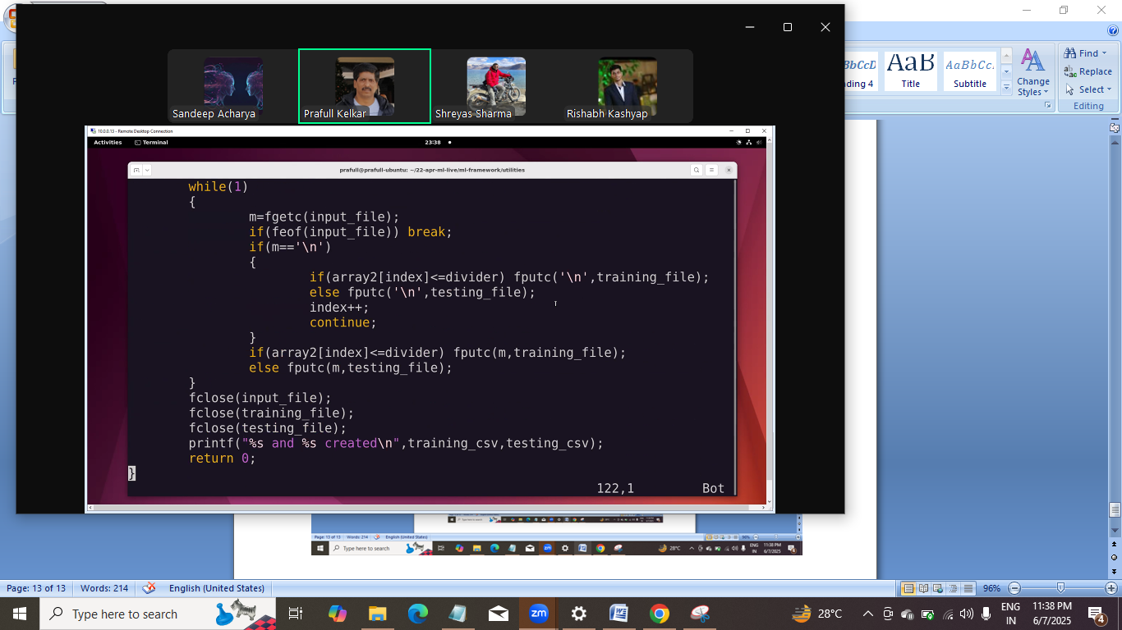

Ab line wale k liye dekhte he:
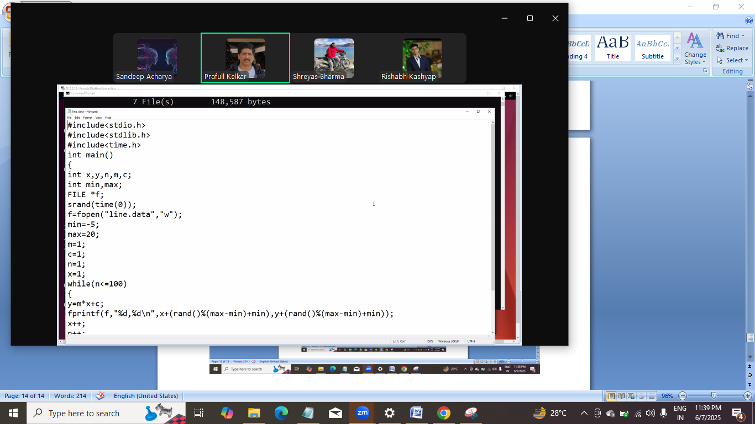

Copy from window to other machine
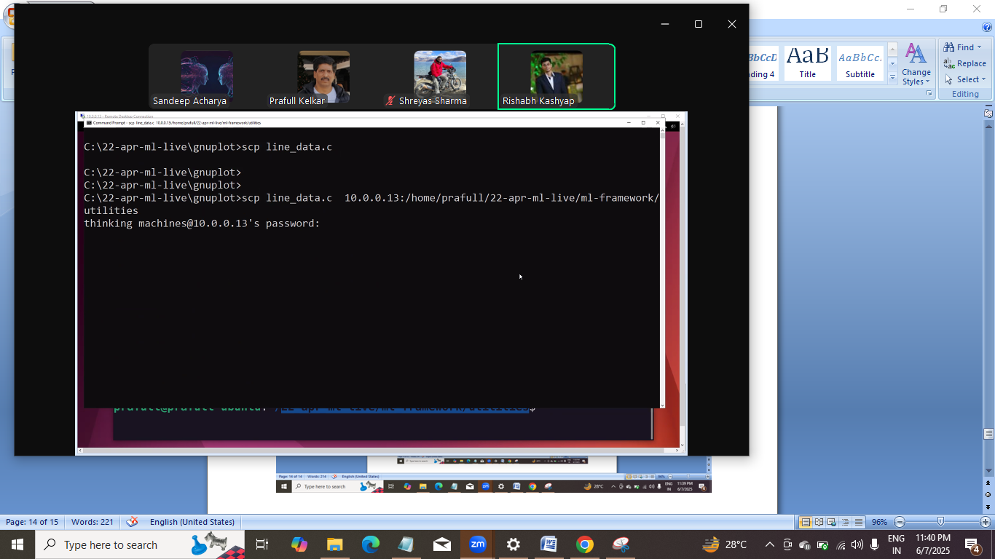
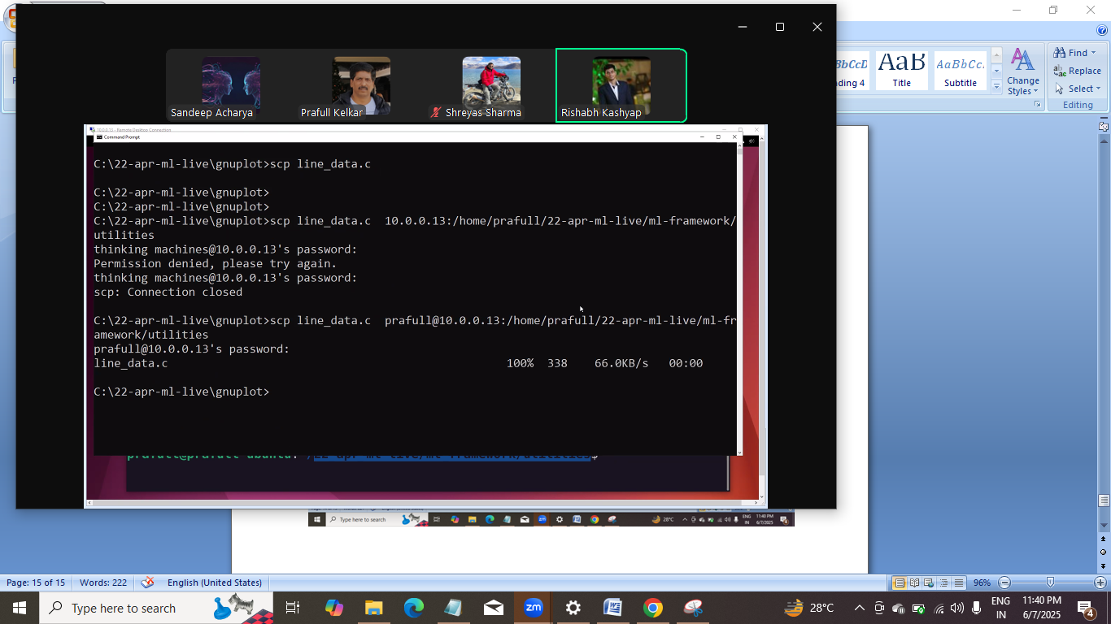

Date: 6/12/2025 6/12 10th june ki chuuti thi

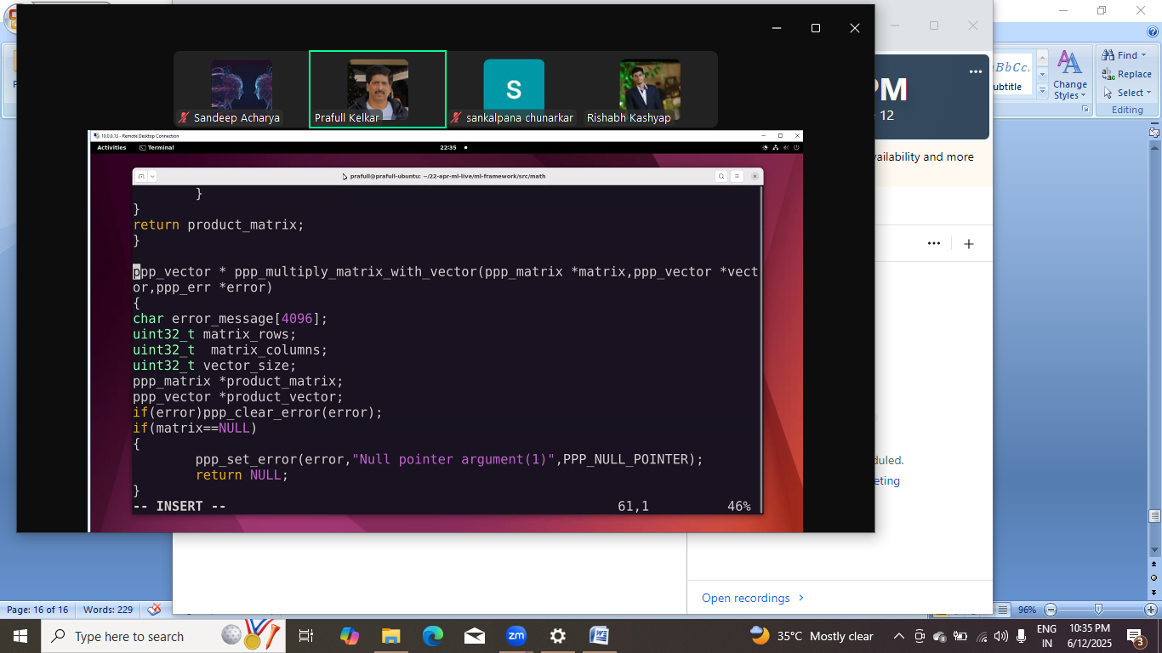
Ye second last l ine chage hogi. Kuch error he product matrix me.
Ab error ko minimize krna he.
And graph ko niche le jana he
Y ko niche lana he and x 0 ki rtaraf bade.
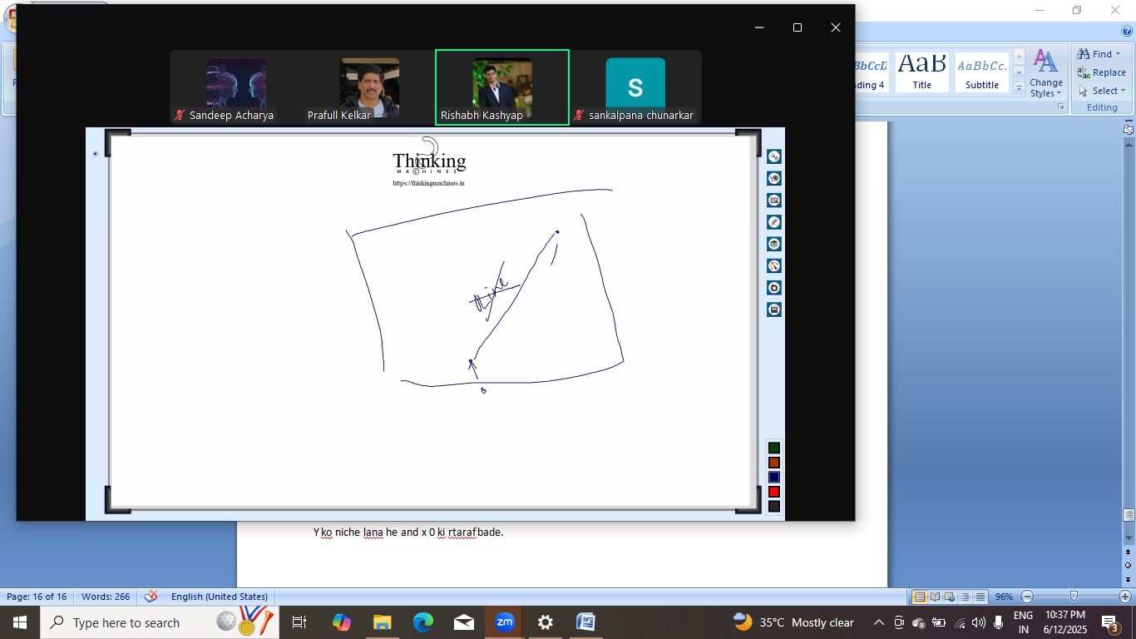
Humko x ki value ese set krna he ki line ki taraf bde , pr line nahi hogi curve jesa bnega.
Differentiation kaam aayega.
1. study of rate of change
2. 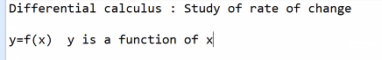
Differentiation is a prcess of computing rate of change of y or f(x).
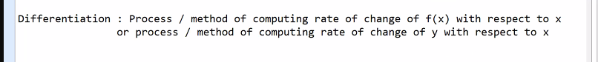
Upar ki process se jo niklega vo derivative kehlayega
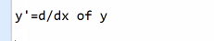
Ab geomatery kisko bolte he.
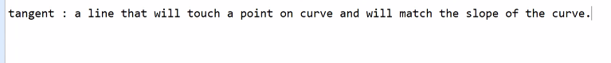
Multiple tangent bhi ho skte he. Yaha pr direction ki baat ho rahi he.
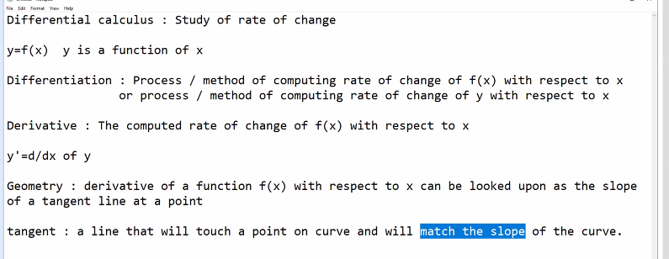

Assignment:
Make curve.c jo cmd argument me start x and end x le
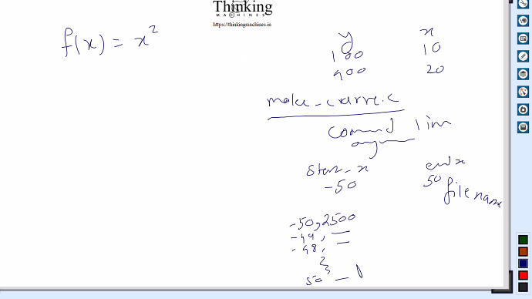
Un dono end k bich ki sari value file me print krna and then us file ko gnu plot pr print kr do.
To curve dikh jayega.

Ab ek tangent bnana he.
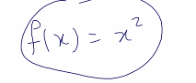
Is function ka derivative nikalege to slope aa jayega.
To is se m nikl jayega and us se c aa jayega.
Esa kr k hum vo
Derivative nikalne k liye power rule aaply krege
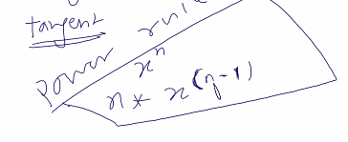
Ye he power rule.
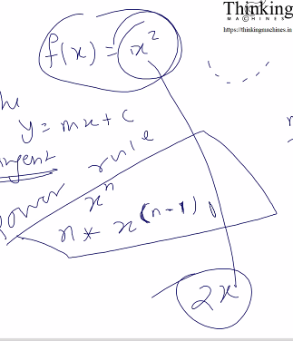
Jese f(x) x^2 k a 2x aa jayega.
Ab humare pass y he jis point k liye tanget line bnana he
Uska x bhi he uska m bhi he as 2x and finally humare paas c aa jayega.
C y intercept ko represent krta he.
Ab 2 baar alag alag x le kr y nikal k line plot kro.
Ek baar m or c aa gaya to koi bhi 2 x ki value le ke .
Final: jo curve bna he usko hatae bina hi humko vo line draw krna he.

Mtlb humko curve ka tangent draw krna he.
Next: ab jo curve se point liye tha vo positive side ka liya hoga. Ab negative side ka lege and usko substritute kr k m and c nikalna.
Phir do x leke do y and phir line draw.

Agle session me ye sb 5 minute me ho jana cahiye.
Humara function to x^2 wala nahi he humara to error km krne wala he.
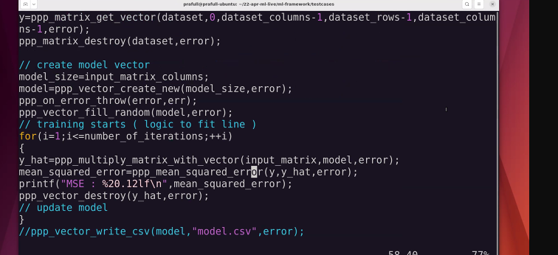
Ye wala.
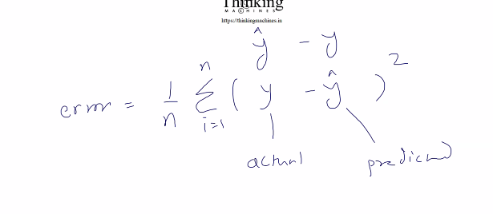
Isko cost function bolege.
Iska humko derivative nikalna he.
Predicted me kuch substitute krna pdega.
A –b ka whole squre krege ko multiple variables aa jayega
Abhi derivative nikala and it can be interpreted as slope.
Ab multiple variable he to partial derivative ki baat aayege. (ye terms next session pdna he.)
AIM: cost minimize krna he.: to is cost function ka partial derivative nikalna he.

Ab naya jhanjat:
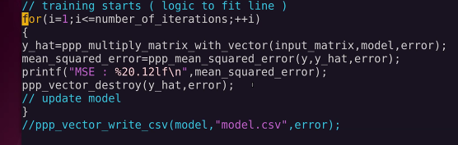
Is code me kuch janjat , logical ko chhod ke.
Memory constraint, baar baar y hat ka bnna , and usko destroy krna.

To memory allocate and release ka time.

Ab jo operation wale function he usko phle se container de to kesa rhega.
And in function ko container do to vo naya bnane k bjaye usi container ko update kre.
Agar naya bnana he to null pass krege.
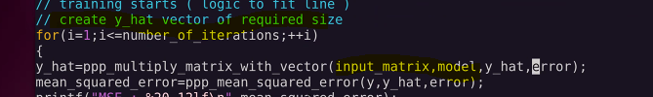
Bs ek parameter bdega and and faltu sa logic.
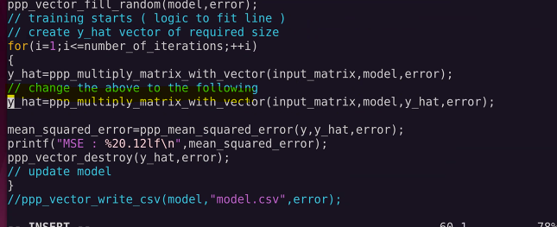
If else me nahi dalna , if argument is not null to prduct vetor = pass kiya gya.
Product vector wale pointer ko create new se assign nahi krege.

Date: 6/14/2025: june 14th this is canceled sir not feeling well

Date: 6/17/2025: june 17th this is missed sir not feeling well [30 minutes ka hua tha lecture] and isme vo container wala argument ka code jiske ss om ne share kiye he.

The last lecture conducted on 6/17/2025 that was absent by me , ss by om on mobile whatsapp.

Ye ss ka kaam ho gya he container bna liya he

Date: 6/19/2025 june 19.
Aaj ka lecture:
Read power rule:
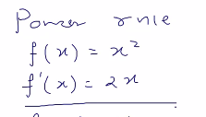
If f(X) = x to kya to isme x ki power 1 to d/dx bnega 1xki power 0 to 1*1 =1;
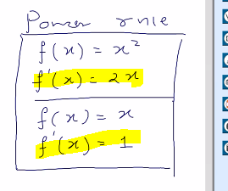
d/dx ki jagah esa highlighted likh skte he.
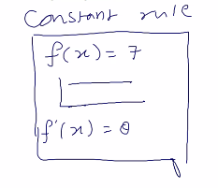
Is case me slope 0 hi rhega. Means x kuch bhi do y 7 hi rhega.
Ab chaning rule:
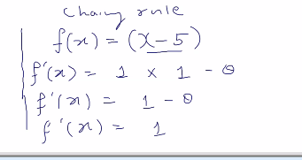

Humri story me jo chaingin rule aayega vo:
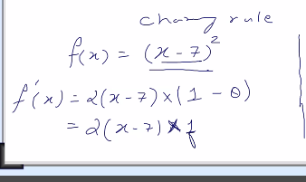
Phle power ko then (x-7) ko isko bhi 2 part me ek baar x ko and ek baar 7 ko
(x-7)^2 pr power rule 2(x-7)
Then (x-7) pr (x^1 -7*x^0)

Ab cost function:

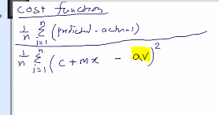
Here av is a constant or isko hum actual vector bolege
Isko kholege to chaining wala rule use krege.
M or c vary krege to predicted alag aayega.
Means hum patially m and c ko change kr k dekhege ki function kese change hota he.
Here why derivatives comes in picture.
How function vary with resect to one variable in it.
Kl mo m and c ki jagah multiple coefficient ho skte he. Like

Step 1. Ek baar wrt c krte he
To isko khola to esa aayega:
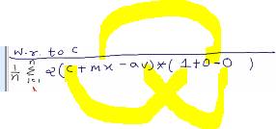 ..
Mx =0 hua coz m is constant and as pr the constant rule isko d/dx =0 and 0*x=0;
Isko programming se realte krte he:
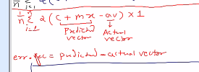
Here err vc is error vector
To final bnega 2*(errorvector*1) where errorvector=predicted-actualv;
Ab agar 1/n ko 1/2n krege to us se ye 2 cut jayega.
By 2 krne se aage ki process me koi change nahi aayega.

Final:
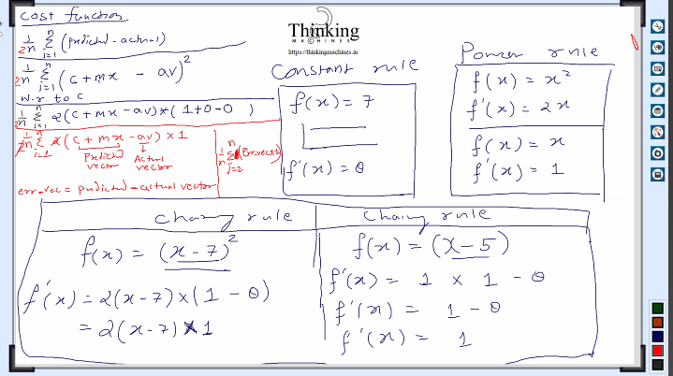

Step2: ab wrt m krte he: to c constant ho jayega, phle wrt to c kiya the to m ko constant mana tha.
To m ka derivative 1 aa jayega ,a nd x change n ahi hoga , phle bhi nahi hua tha
Ye update rule he: m k respect me function kesa behave krta he like kese change hota he
And c k respect me kese change hota he.
Usi ko dhyan me rkhte hue unke repesctivre partial derivative lege.
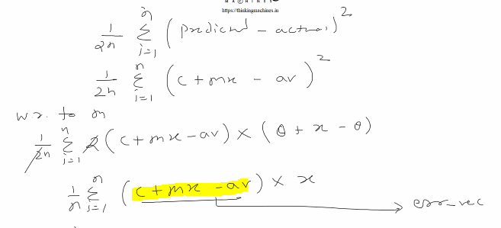
C+mx-av = 0 +x-0
Coz c is constant here and m is variable and x as it is uska d/dx nahi krna he av is constant. Actual vector
Ab ye highlighted ko error vector maan le
To final derivative wrt m will be
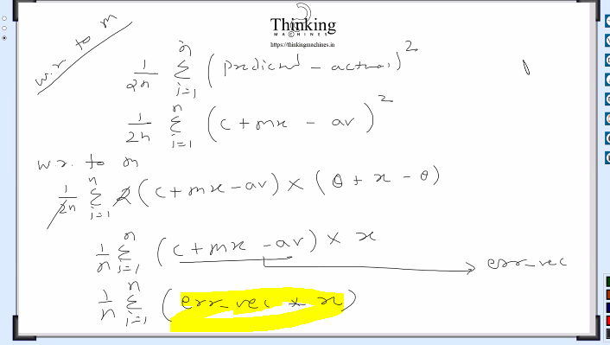
Ab
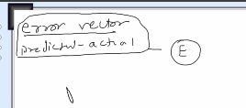
Error=predicted-actual to usko E se represent krte he.

To humara final derivatie bna: wrt c and wrt m
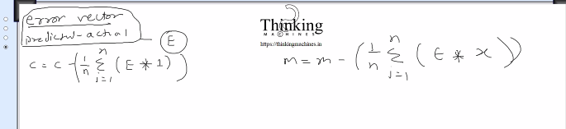
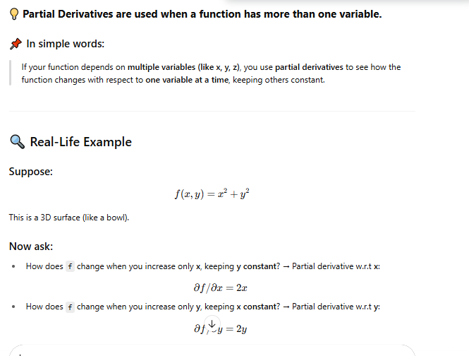
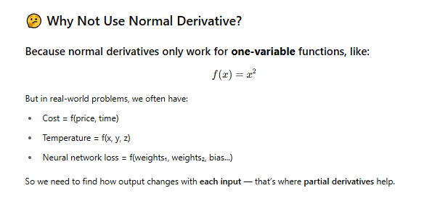
In our example our changeable Inputs are m and c so we will find how f(x) chane with each m and c that’s why we used partial derivative. Here.
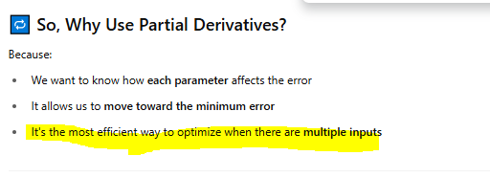
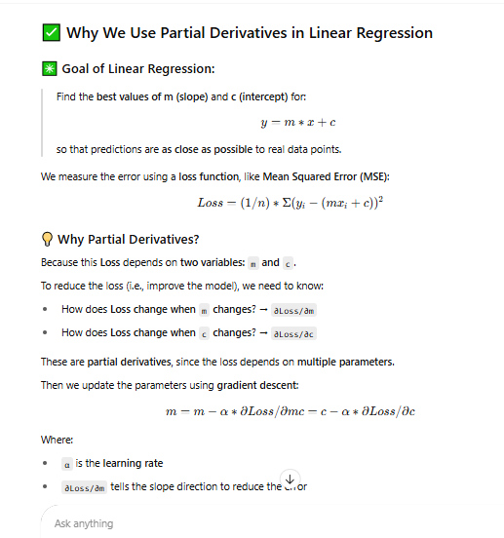
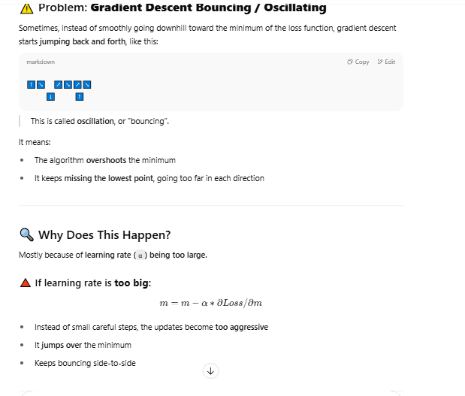

To esa kr k humne m and c ki value update kri.
But why we are substracting it here?
May be a rule? Like power rule, addition rule , let see on later.
Abhi bahut saare derivatives aayega, yaha to ek m and ek c he.
Agr ye final update rule hota(he to nai) pr hota to:
To humari programming me model vector he 2 elemnet ka :
Input single the and humne ek constant ghuseda.
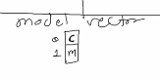
Isme 0 index c and 1 inex m ko represt krta he
Read why we do derivative;.
Kyuki udr input matrix me first col pr filled value 1 he and 2nd col pr x variable ki values.
Ab x kya he: input vector
Isko input matrix me convert kiya vo ek column me 1 add kr ke ese
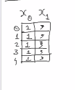
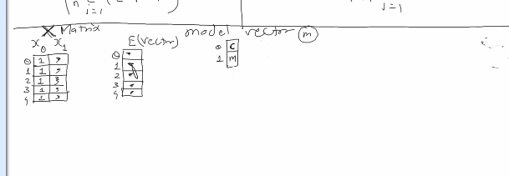
Ab humare pass X matrix Evector and model vector he
Ab humko X ko E se multiply krna he to X ko transpose krna pdega.
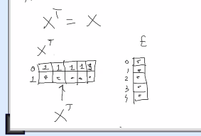
Ab xt and E ka multiplication and kuch to bhi k mil raha he.
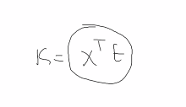
To kya yahi k ko is se relate kr skte he kya
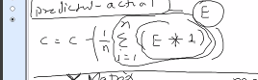
1= x0,0 x0,1 x0,2 x0,3 x0,4
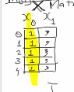

Then
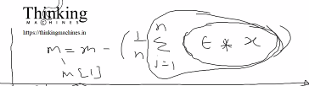
x= x1,0 x1,1 x1,2 x1,3 x1,4

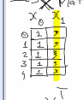
Isko kholege to vesa hi bnega
Ab board pr pura vectorize solution aa gaya he.

Final:
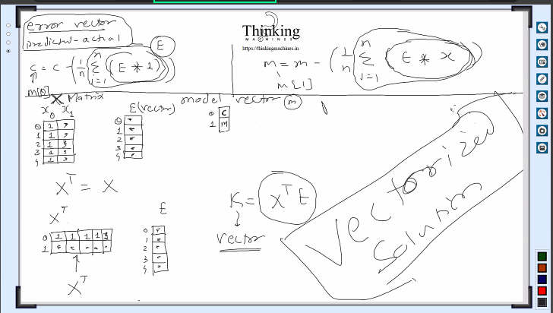
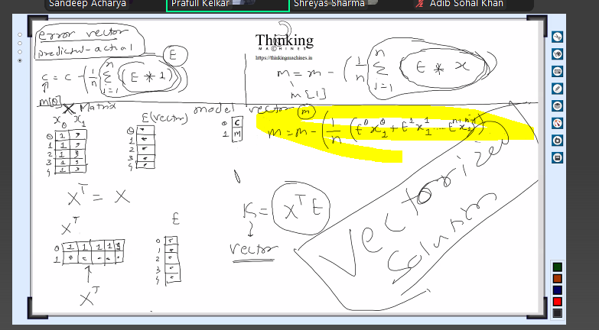
How come this is going to minimize error: iske upar discussion krege

Vectorize solution hi hona jaruri he esa kuch he kya ? no but parallel programming jaha he vaha he.
Update rule bhi final nahi he.
Purana wala code pura change krnah pdega.
Pura control humare hath me lena pdega ,
And container wale approach se jldi ho jayega.
Error container, transpose container , m=m- k liye container.
Temporary containers ki bhi jarurat.
Abhi update rule incomplete he usko bhi complete krna he.544

Date 6/21 June 21, 2025
Update rule ki baat kri thi pr vo final nahi he
Now if:
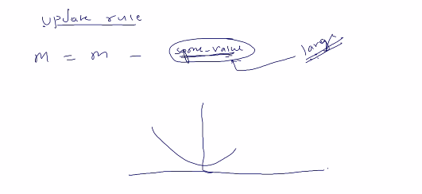
Some value large hui to u turn bn jayega, x se –x and –y me aa jayeg
Hum nahi chahege ki m ki value bade figure se change ho. Esa hua to shoot ho jayega and error km hone ki jagah bd jayega
To m ko chhota hi rkha jaye
To isko chhota krne k liye kisi se multiply krege like 1/100 , 1/1000, 1/1000 trial wali baat.
Some value is partial derivate krne k baad jo aayi vo.

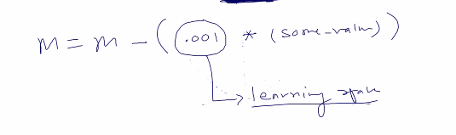
Jis se multiply kreege usko learning rate bolege
Ab jo humne vo 1 wala column liya tha vo vectorize solution nikalne k liye usko bias bolege
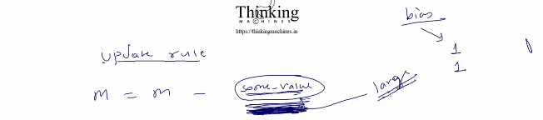

Note: partial derivative nikalne se esa kya hoga jo error km ho jayegi.

Ab sudo code bnayege.
Humne jo main me code likha tha vo memory ki waat lgane wala code
Python me koi bnayega vo to memory ki waat lgane wala hi bnayege.

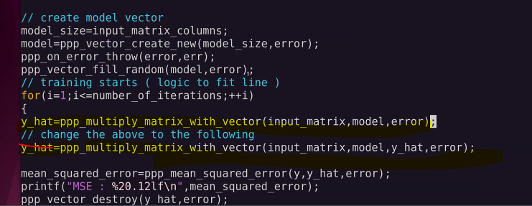
Ye tha vo useless wala code

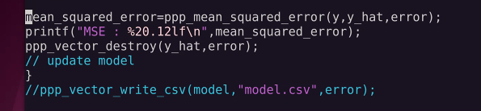
Ye pura code rewrite hoga.
Now steps:
Ye he file
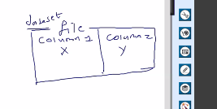
Isko X matrix me load kiya
Ek data file he jisme col 1 and col2 , the below is isrrespective of library support and languages
- Load dataset in x matrix
- Extract y vector from x matrix[ means y ko alag vector me copy kr diya]
- Us y coll me 0th wala shift kr dege and usme then 1 copy kr dege
- Move 1st col into second col jiska data vector me daal chuke to vo useless he to ab usme 1st col copppy kr skte he Fill 1 in first col
- Create Xt x ka transpose kiya, esa transpose coz ek error vector hoga 1 col 5 row and humare pass 2 col and 5 row , inko aapas me multiply krna ho to 2 col wale ko transpose kr k 5 col 2 row me convert krna pdega.
- Prepare containers:
- Diff vector error vector hoga isliye E lege
- Model vector ki size X k column ki size ka rkhege.
Yhat is X *M [input into model vector]
E is Yhat –Y [ye error aa jayegi]
Compute error value
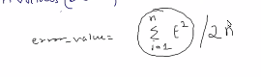
Ye sum compute krne ka formula he. N(n-1)/2 ,isliye ye formula liya he.
Isko kese kre, vectorize form me ya kuch, vectorize form me kya krna pdega.

Hamesha 2 vector ka multiplication humesha scalar value hogi kya? No
e.g
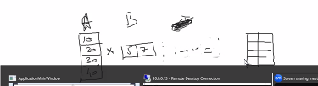
Is case me matrix bn raha he.
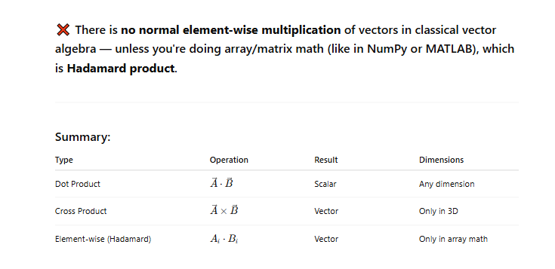
To ye to result nikla usko naam dege ETE that is E^t * E
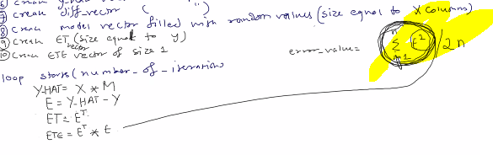
Yaha pr error square and sum dono ho raha he.
To is ETE me sum bhi he to humari error value isi se nikal lege
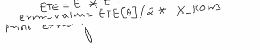
Why divide by 2 and into x ki ro

Final:
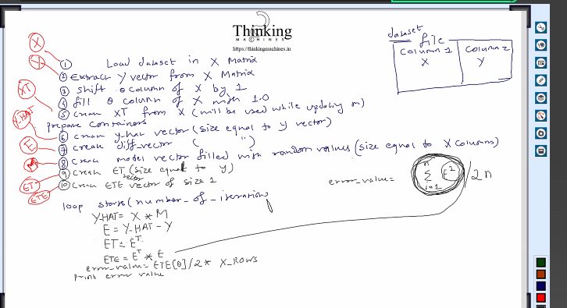
Ab is se humare paas ye chize haath lgegi
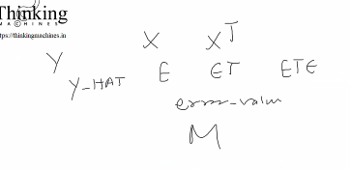
Ab Model vector ko update krna he
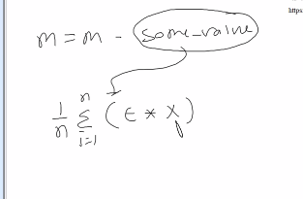
Ab yha X ki jahag kiya rkhe ans: X^T
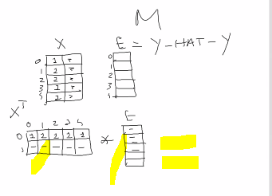

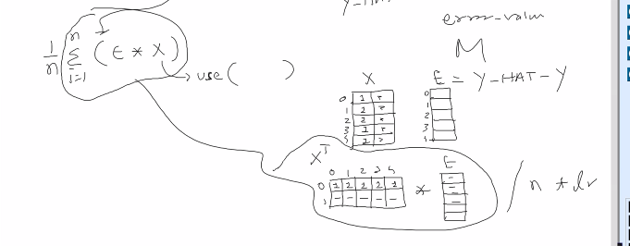
Final divided by n and multiply by learing rate.
X^T * E ka result ek vector bnega jiski size = column of input matrix X = size of model vector.
Ab humare hath XTE bhi lg gaya. Step 11.
Ab humko some_value

Note: isko board pr practice kro update rule ko , update rule ko rat lo
Abhi to data set m 1 feature he , kl ko 50 feature hogi to bs humare logic ki ek line change hogi
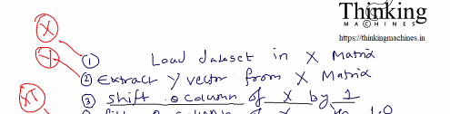
Shify by 49

Ab
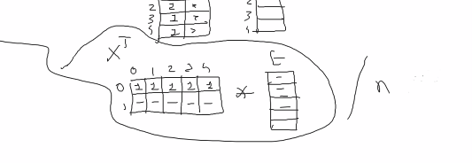
Ye element wise divide hoga.
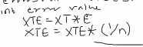
Ab multiply by learning rate.
Ab model vector ko update krne ka kaam:
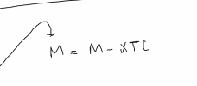
M me hi update kr dege , container ki jarurat nahi
Ab loop end
Is algo me goto wali baat nahi likhi kuch error aa jaye to.
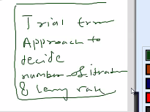
Trial error se no of iteration kitne and learning rate kya , ye tay hoga
Ye final wala ss.: algo for linear regression.

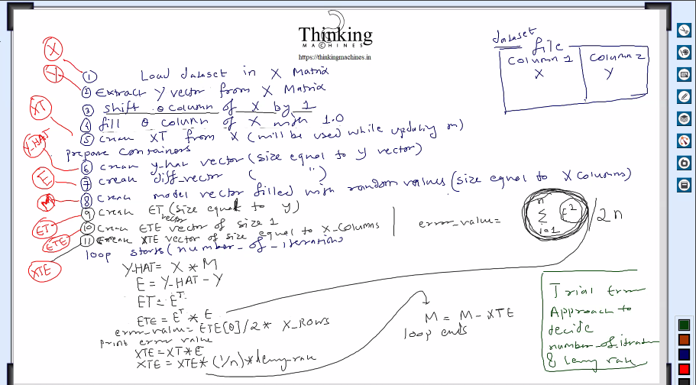
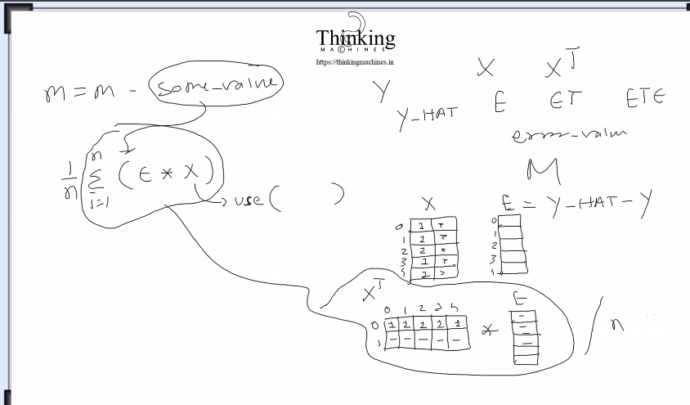

Date: 6/24 June 24, 2025
Teams k liye chatboat bnaya: to impress interviewer
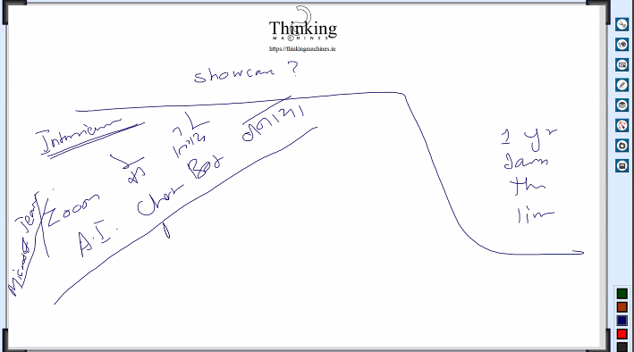
Jo ye chatboat bnayega vo AI engineer kehlayega, pr vo krega kya.
Sdk use krege. : sdk k through login , then join then de fine callbacks jis se audio and video stream milegi and speech ka text bhi mil jayega along with who speak.
Ye sb sdk k piche wali api de rahi he.
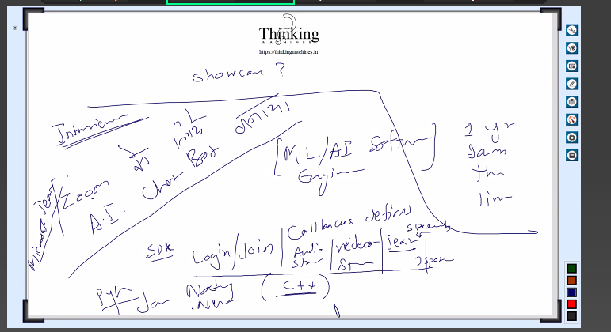
Data liya openai ko bhej diya and response liya and idr dikha diya and finally AI developer
Why anybody spent recreating something if it is already available.
Microsoft team ki api is cost .
Microsoft ki api k paas to alag alag hi aa raha he
Ms k sdk ko bypass krne jayege to system k audio video record kro and then process kro, bahut jhamele
Is se cost zero but jahamele bahut.

To ab hum jo showcase kr rahe he vo kese kre.
Ans: khud ki website bna k.
Jispe linear regression implementation ka example jo dusre log download kr k run kr le
Dusradata set kese use krna he vo bhi documented krege.
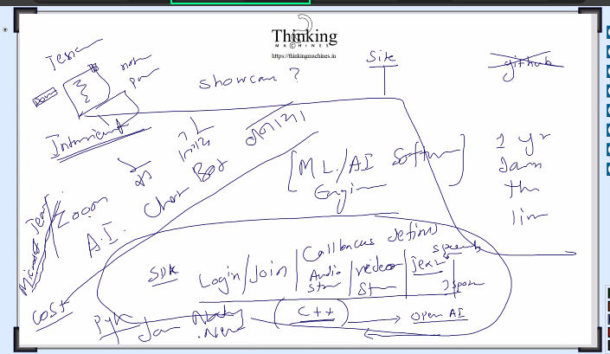
Document me parameter ka khel he.
Ye kese achieve krte he:
Jis tech me kaam kr rhe he usme sikhe ki kese docment kre
Humare server ka 30000 per year ka kharcha he.
Dnfv
Ab linear regression ka ek function bnayege usme input x then y then no of iteration then learning rate then error and finally it will return a model vector.
Is function me container ki jarurat nahi he kyuki har baar model naya hi bnega.
10 din tk chlne wala koi process ko har din 9 ghante chlana and at eod us result ko ek model me store krna he. Then Pehli cycle ka data leke , dusri cycle start krna to uske liye ek model ka parameter bhi rahega. Ye baaad me dekhege
Then
Jjk
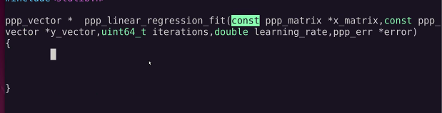
Is function k andr k variable ka documentation me koi kam nahi kesa bhi le skte he,
Error vector ko hi difference vector liya he.
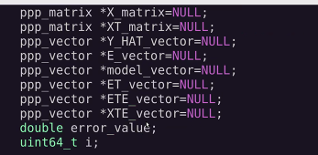
Ye final internal variable based on the previous lecture discussion.
Kisko matrix liya and kisko vector liya ye dhyan rkhna he.
Abhi skbo destroy bhi.
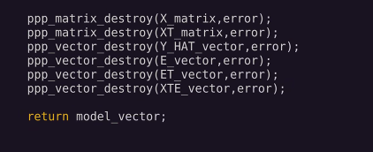
And finally return model vector
Ab labellling.
Error function jis tarike se likha us hisab se call krna he
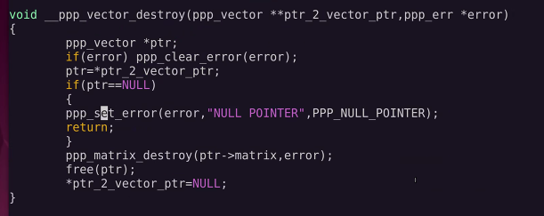

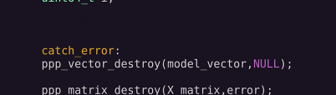
Ab catch error me error ka refrence dege to vo usko bhi clear kr d ega and jis error ki vajah se catch me fasa vo bhi clear ho jayegi
But destroy me esa likha he ki if not error to koi clear nahi

To null pass krege
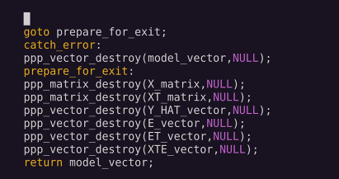
Final.
Error messages is function ko call krne wale ko mil jayega vo us address pr hi likhayegi error.
Ye null check bhi laga diya
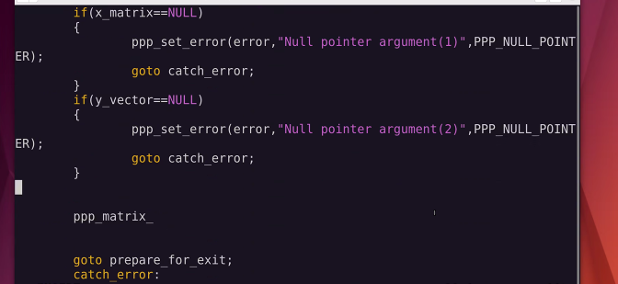
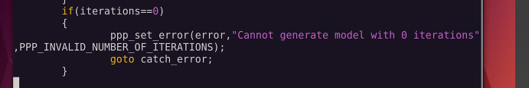
Ab matrix k dimension nikalne ki baat
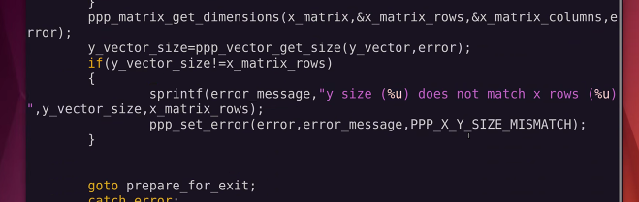
Dimension lene k baad vo size wala check.
X is input feature ka set and y is target output.
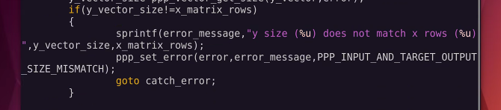
Ab X matrix bnate he:
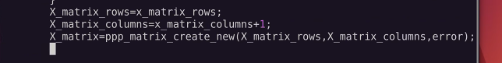
Ab is matrix ko fill krna.
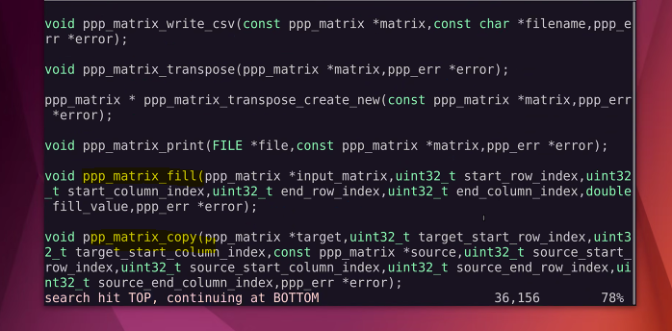
Yaha se fill and copy kaam aa jayege.
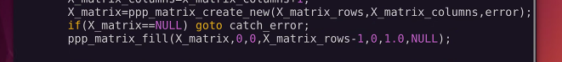
Target, strt row index, end row index than start col indext end col index.
Ye fill krne kaa kaam ho gaya.

Ab sudo k hisab se shift krne ka kaam ho gaya he.
Ab transpose kaa kaam
Transpose ko bhi container de skte he.

Ab y hat:
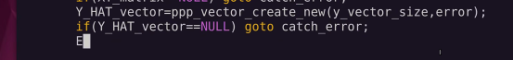
Ab E vector or diffrece

Ab ET ETE XTE
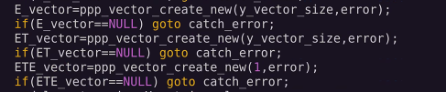
Ab model vector and usko fill
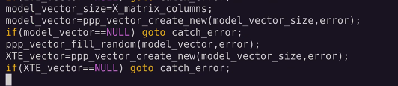

Ab loop
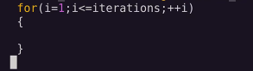
Ab nex
Main pura change hoga bs vo input read kr k alag alag krne wala code rhega.

Aaj ka code:

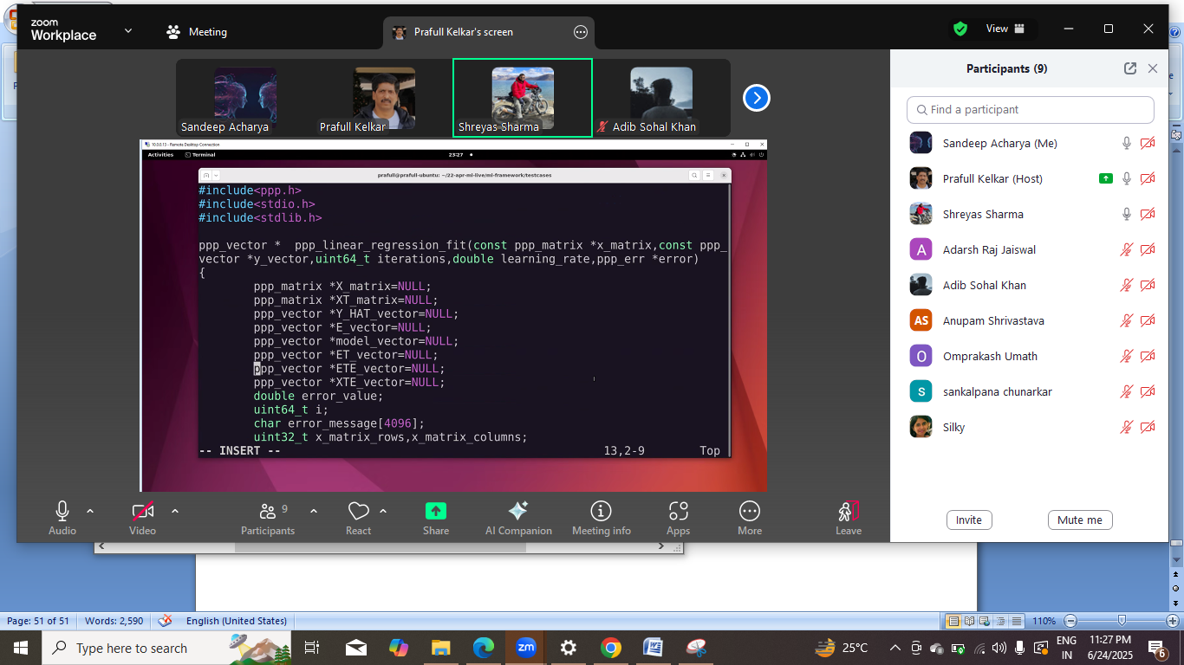

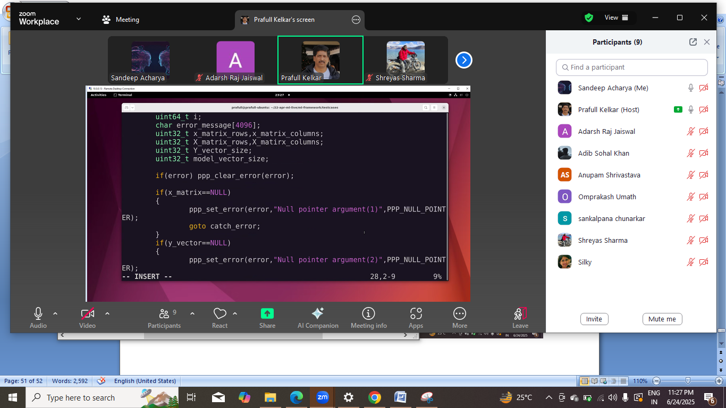
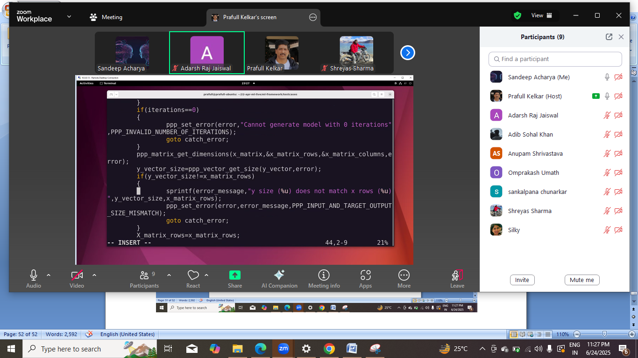
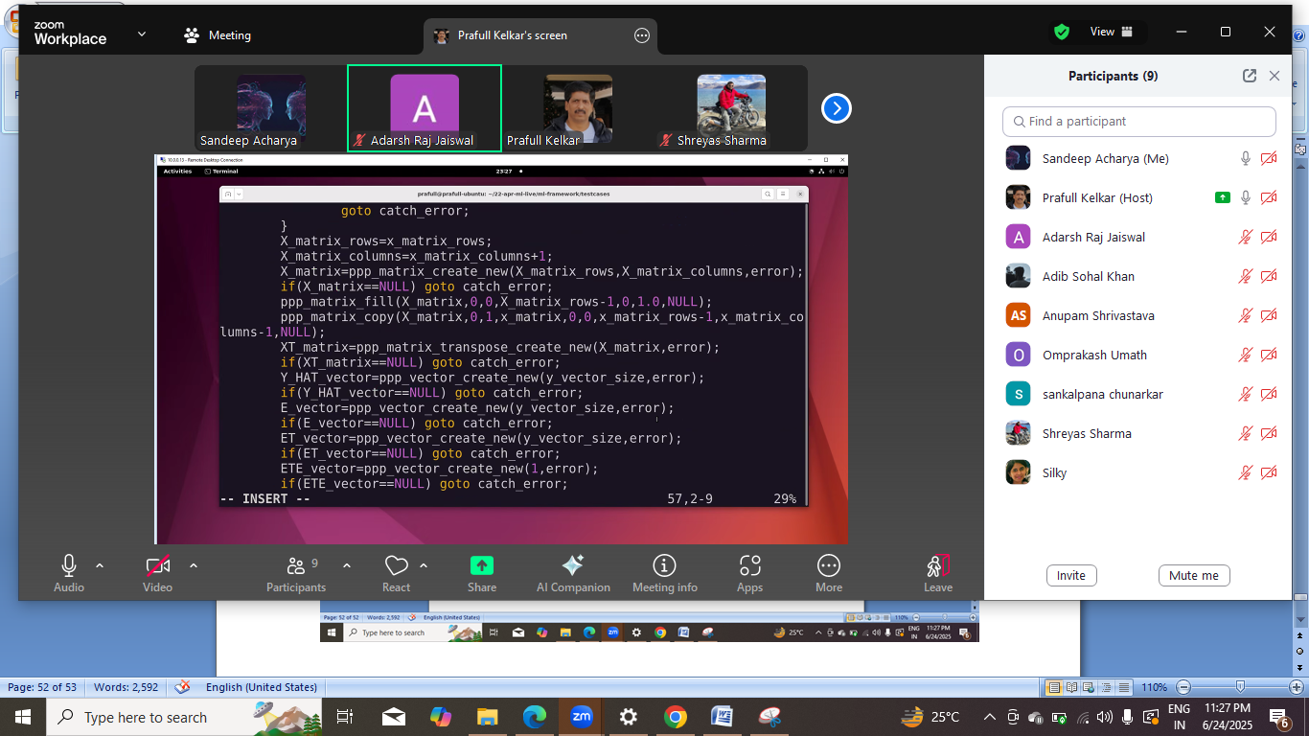
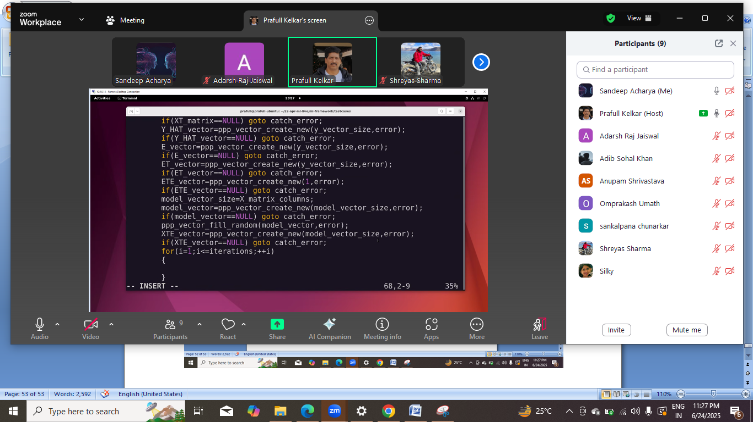
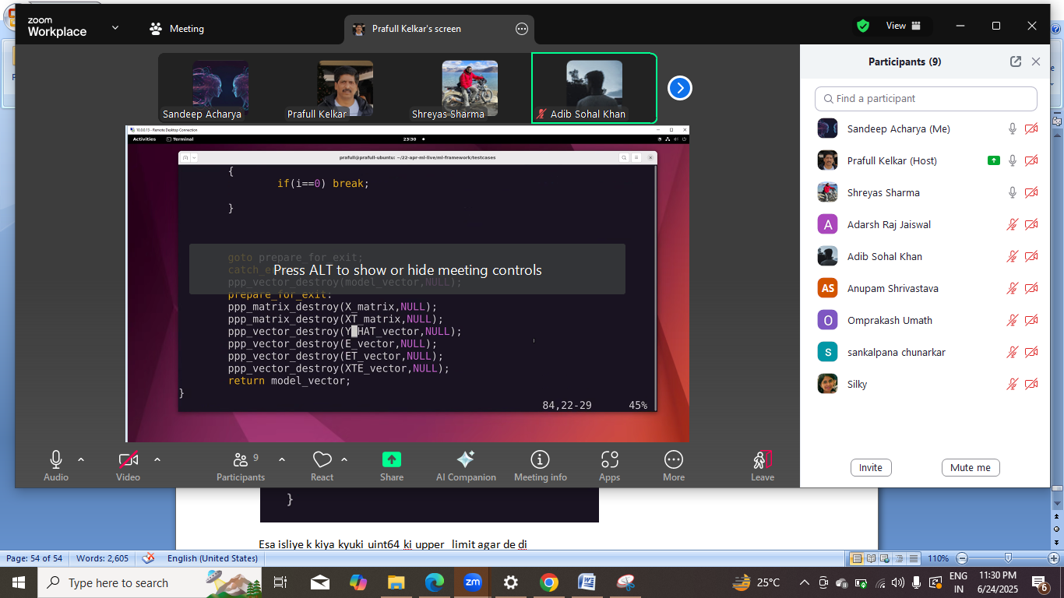

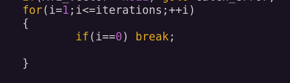
Esa isliye k kiya kyuki uint64 ki upper limit agar de di to vo 0 ho jayega.
Actual me huge number k liye kya krte hoge.
Khud ka ds bnate hoge like string le k usme operatin krte hoge.
Let se 32 bit ka ek int abhi humko 128 bit k chahiyye to ek array le lo 4 element ka.
Saare primitive ka equivalent wrapper
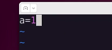
Like a=1 se jo code chlega usme 1 ko kisi object me wrap kr k rkh diya jayega.
Look at everthing as an object;.

